Archeological Society of Virginia 2022
82nd Annual Meeting
Call for Student Papers and Posters
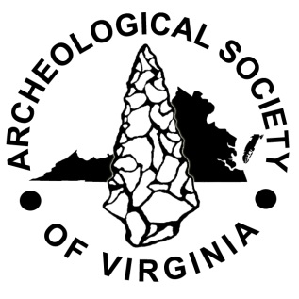
http://www.virginiaarcheology.org

The Archeological Society of Virginia (ASV) is seeking papers and posters from undergraduate and graduate students to be presented at its Annual Meeting, which will be held this year at the Fort Magruder Hotel and Conference Center, 6945 Pocahontas Trail, Williamsburg, Virginia, October 21-23, 2022. The presentation should be no more than 20 minutes in length and a PowerPoint slideshow is encouraged. Posters should be no larger than 36 inches by 48 inches.

The ASV will sponsor conference registration, banquet ticket, and one-year membership in the organization for all student presenters.

By Friday, September 9, 2022 send presentation or poster abstract to Dr. David Brown, ASV Program Chair via email (dabro3@email.wm.edu) and Dr. Stephanie Jacobe, ASV Education Committee Chair, via email (stephaniea.t.jacobe@gmail.com).

Please complete the form below and submit with the abstract

NAME _____________________________________________________________

COLLEGE/UNIVERSITY______________________________________________

ADDRESS __________________________________________________________

CITY STATE _________________________________ZIP ___________________

PAPER/POSTER TITLE _______________________________________________

E-mail ______________________________________________________________

I will be presenting a PAPER_________ POSTER_________

*Participants must register for the meeting and banquet and will be reimbursed through the ASV’s Student Sponsorship Program at the registration desk.
Check out http://www.virginiaarcheology.org for more information as the Annual Meeting approaches.

